FACULTY OF COMPUTER SCIENCE AND ENGINEERING

Ghulam Ishaq Khan Institute of Engineering Sciences and Technology, Topi

Lab Duration: 3 hrs. CS311L Operating System Lab Marks: 10

Lab No: 7 Instructor: Ms. Mah Rukh Date: 12-11-2024 Muhammad Bilal 2022360

**Lab Activity 7**

**Task 1:**

**Write a C program to create a child process and display both the child’s and parent’s Process IDs using getpid() and getppid().**

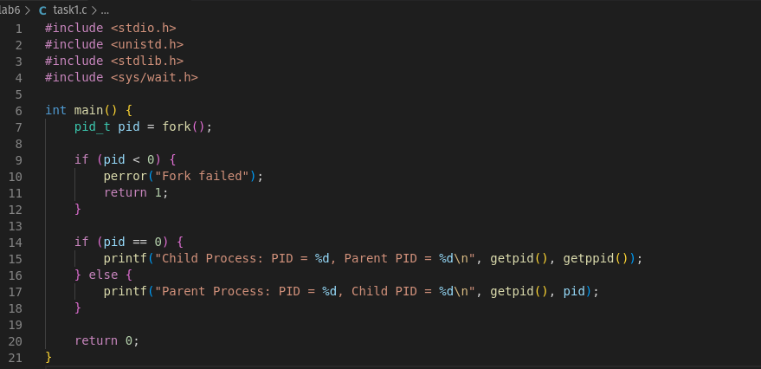



**Task 2:**

**Create a child process that performs a simple task, and use wait() in the parent process to ensure it waits for the child to complete before resuming.**

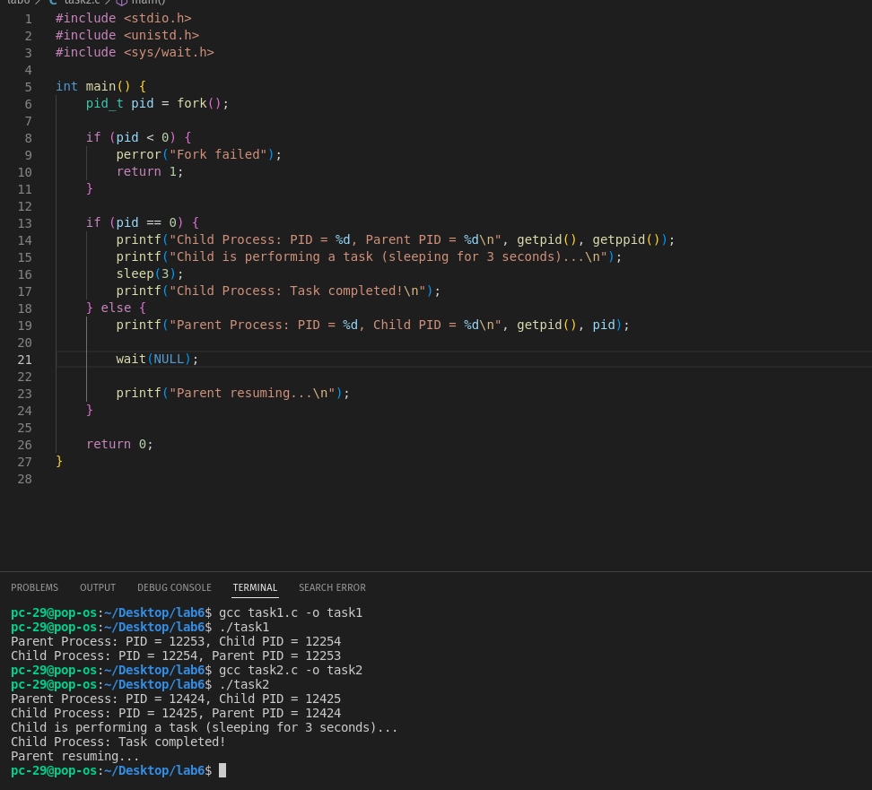

**Task 3:**

**Write a program to create three child processes, each with varied sleep durations, and use waitpid() in the parent to manage and display each child’s termination status individually.**

